Job Title: | Dental Therapist | 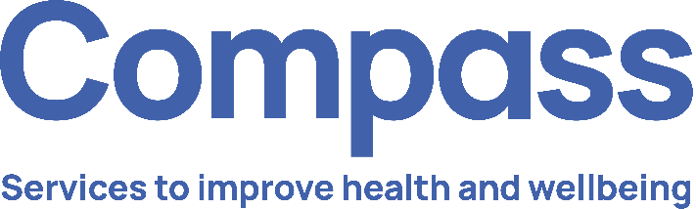
Job Grade: | F
Reports To: | Clinical Manager
Service Overview:

Tower Hamlets Young Health hub is a truly integrated early intervention and health promotion public health service for children, young people and their families living in the London Borough of Tower Hamlets. The service provides a unique multi-professional school health and wellbeing model delivered to children, young people and families (CYPF) in an accessible way in schools and communities.
The service provides a range of clinical and non-clinical health and wellbeing interventions alongside health promotion activities, including:
- School Nursing
- National Child Measurement programme.
- Early Intervention Substance Misuse and Risky Behaviours.
- Sexual Health
- Oral Health
- Community awareness raising.
- Vision and Hearing Screening.
The Young Health Hub works collaboratively with communities, partners and CYPF to design, develop and deliver holistic wellbeing services which reduce long-term ill health, remove or reduce health inequalities and create opportunities for CYPF to take and sustain positive health promoting action.
Job Purpose:

To provide preventive, educational and clinical dental services to children and young people within schools and community settings, promoting oral health, preventing dental disease, and supporting access to dental care for vulnerable populations.

The Dental Therapist will provide preventive, restorative and oral health promotion services for children and young people within school and community settings. The post holder will work as part of a multidisciplinary team to assess treatment needs and refer children requiring specialist or further dental care to appropriate services, improve oral health outcomes, reduce oral health inequalities and support children to access appropriate dental care.

The post holder will undertake clinical assessments and treatments within the General Dental Council (GDC) Scope of Practice for Dental Therapists and contribute to the planning, delivery and evaluation of school-based oral health programmes including Brush for Life, Supervised Toothbrushing and oral health promotion and education. The role will include direct work with children and young people (CYP) as well as schools, families and partner agencies to promote good oral health and wellbeing

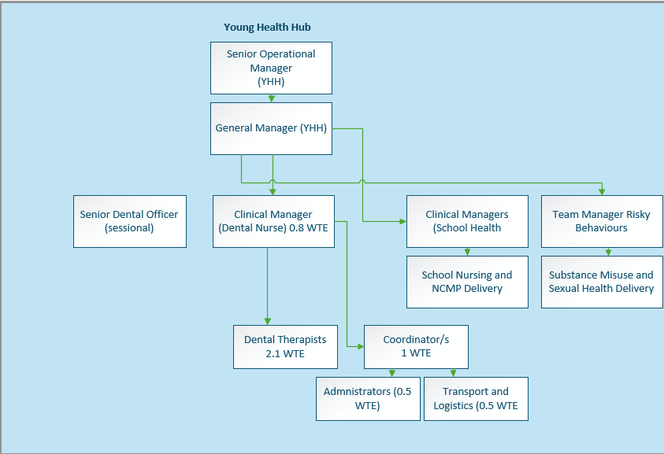

Key Duties and Responsibilities:

- Operational

  - Carry out dental assessments and oral health screenings in schools.
  - Undertake fluoride varnish application.
  - Identify children requiring further treatment and arrange referral to appropriate dental services.
  - Make provision for the appropriate consent arrangements effectively recording and managing consent.
  - Maintain accurate clinical records and documentation
  - Deliver evidence-based oral health education programmes to children and young people, parents and carers, school and partner agencies and community groups
  - Support the implementation of supervised toothbrushing programmes and preventative oral health initiatives in schools, nurseries and community settings.
  - Advise on healthy eating and sugar reduction to improve oral health.
  - Promote positive oral hygiene behaviours and preventive care.
  - Participate in national dental epidemiology surveys and school-based screening programmes.
  - Support safeguarding processes and the identification of vulnerable children
  - Promote well-being and address inequities, by reducing disparities in oral health through targeted prevention and early intervention initiatives.
  - Maintain up-to-date health protection standards and demonstrate compliance through clinical audit or other means.
  - Establish, monitor, and maintain high standards of Infection Prevention and Control.
  - Implement a programme of oral health promotion in nominated nurseries/schools/education settings and community venues.
  - Provide age-appropriate oral health programs in schools and communities for children, youth, families, and professionals.
  - Attend and contribute to multidisciplinary meetings relating to children's health and wellbeing as required.
  - Participate in service audits and quality improvement projects
  - Working with colleagues and departmental leads contribute to the development of high quality and evidence based procedures, policies and operating guidance.

- Developing and Maintaining Relationships

  - Work closely with schools/settings to promote participation and engagement.
  - Effectively engage schools/settings to establish and maintain expected standards of provision in the supervised toothbrushing programme and acts to support compliance. , school nursing teams, public health teams and community dental services.
  - As part of the Young Health Hub works collaboratively across the multi-professional team to deliver coordinated activities in schools/settings and the community.
  - Promotes the service and organisation through proactive, helpful and expert engagement with partners.
  - Champion oral health promotion throughout Tower Hamlets by equipping parents, professionals, and schools to teach children about dental care, support early detection and referral of oral health needs, and deliver preventive programs like supervised toothbrushing and fluoride varnish.
  - Participate in partnership working with other relevant agencies including mutually agreed reciprocal staff training where appropriate for key staff groups to build community capacity and effective use of community-based assets.
  - Works collaboratively with the Young Health Hub colleagues to plan integrated, holistic and cohesive public health campaigns for oral health, diet, weight and associated health priorities.

- Managing Resources

  - Works to high standards of maintenance, calibration, safety, and sufficient supply of equipment.
  - In collaboration with team coordinators and logistics colleagues ensures sufficient supplies of oral health packs and provisions to maintain service delivery.

  - Works closely with Health Visiting and Local Authority colleagues to identify required resources and support the effective use/distribution and application of oral health products and equipment.
  - Design, develop, distribute and review a range of digital, written and creative education resources.

- Managing Self

  - Maintain GDC registration and professional standards.
  - Adhere to infection prevention and control procedures.
  - Participate in clinical audit, supervision and continuing professional development.
  - Ensure compliance with safeguarding, confidentiality and data protection requirements
  - Prioritise own workload within agreed objectives using your own initiative.
  - Take responsibility for own learning and professional development in line with Compass’ Learning and Development framework and maintain compliance with mandatory training requirements of the role.
  - In conjunction with your line manager, take responsibility for shaping and directing your assigned equalities themed lead area of work and supporting others in the development of their themed/high impact area
  - Take responsibility for your own and others’ health and safety in the working environment.
  - Promotes equal opportunity and diversity within Compass.
  - Ensure that confidentiality is upheld at all times in line with Compass policy.
  - Ensure safeguarding responsibilities are delivered in line with role and competency level.
  - Work in accordance with Caldicott principles and Data Protection principles and adheres to all relevant Compass policies, procedures and guidelines
  - Maintain accurate records in line with the Compass policies and procedures
  - Skilful at managing conflict that may arise whilst working on behalf of Compass
  - To act as a role model in applying good infection control prevention and control policy and practice within Compass.
  - Maintains own professional registration.
  - Participates actively in own development, supervision and appraisal with the General Manager and Senior Dental Officer.

Flexible Approach
5. Flexible Approach
To undertake any evening or weekend working as required; periodic, planned work outside of normal working hours may be required from time to time to engage in schools/setting with parents and strategic partners.
To carry out such other duties commensurate with the grading of the post as may be reasonably determined from time to time.

In line with Compass Values and Character be a creative problem solver, flexible and proactive
in enhancing, developing and promoting delivery and reputation of the oral health service.

In addition to these functions the post holder is expected to:

In agreement with the line manager carry out such other duties as may be reasonably expected in accordance with the grade of the post.

6. Financial Responsibilities: None
7. People Responsibilities: Is responsible for the supervision, support and induction of new or junior colleagues and learners on an as and when required basis.

Qualifications, Experience and Knowledge:

ESSENTIAL
Qualifications

- BSc/Diploma in Dental Therapy or equivalent.
- Current General Dental Council (GDC) registration.
- Certificate in Fluoride Varnish Application

Experience

- Experience of delivering clinical dental therapy services.
- Experience of health promotion and preventative dental care.
- Experience of working with children and families.
- Experience of maintaining electronic patient records
Knowledge

- Knowledge of public health approaches to improving children's oral health.
- Clinical record keeping standards and practices.
- School based oral health policy, provision, standards and aspirations.
- Knowledge of GDC Scope of Practice.
- Understanding of safeguarding children procedures.
- IT literacy including electronic clinical record systems
- Knowledge of infection prevention and control.
- Knowledge of equality, diversity and inclusion principles

Personal

- Excellent communication and interpersonal skills.
- Ability to engage effectively with children and young people.
- Strong clinical assessment and treatment skills.
- Presentation and group facilitation skills.
- Ability to work independently and as part of a multidisciplinary team.
- Ability to prioritise workload and manage competing demands.
- Team working and relationship-building skills.
- Organised and able to work flexibly to meet changing needs.
- Ability to commute efficiently and effectively around the London Borough of Tower Hamlets

DESIRABLE
Qualifications

- Additional qualification in oral health education or public health.

Experience

- Experience in support of supervised toothbrushing programmes.
- Experience working with children with additional needs or vulnerabilities.
- Experience of teaching and presentation
- Experience of delivery of Fluoride Varnish to children and young people.

Knowledge

- Understanding of population health and health inequalities in oral health.
- Knowledge of public health approaches to oral health improvement.
- Knowledge of school health systems and education settings
- Understanding of the role of population and clinical audit in public health.

Personal

- Driving Licence

Key Competencies/Personal Attributes:
The post holder must demonstrate strengths in the following competency areas:

- Team Player – able to work as part of a team, co-operate to work together and in conjunction with others and willing to help and assist whenever possible and appropriate.
- Interpersonal skills – able to develop, establish and maintain positive relationships with others both internal and external to the organisation.
- Strategic Thinking – able to identify and manage risk.
- Confidence and Presentation Skills– able to deliver messages in a confident manner, with excellent presentation skills and group work skills.
- Communication skills – excellent communication skills (both written and verbal) and ability to adjust communication style and content to the audience.
- Resilience and Workload Management – able to work under pressure, dealing with peaks and troughs in workload and see tasks through to completion when under pressure.
- Flexible & Adaptable – positive attitude to dealing with change; flexible and adaptable, and open to exploring new ideas.
- Self-awareness – ability to empathise with others, maturity to admit and rectify mistakes and strong degree of personal integrity to adhere to acceptable standards of behaviour.
- Motivated – highly motivated and reliable and organised to plan and meet deadlines and manage time effectively.

Compass Values:
The post holder must demonstrate exemplary behaviour in all Compass values, personifying the values and inspiring all colleagues to do the same:

We are Solution Focused
We believe in the art of the possible
We believe in being courageous and collaborative

We Act with Integrity
We believe our actions speak louder than words
We believe in asking for and offering help

We are Consistent & Reliable
We believe tenacity leads to success
We believe that no effort goes to waste

We Value Each Other
We believe in treating others as we expect to be treated
We believe everyone has something to contribute regardless of role

Safeguarding:
The post holder must demonstrate and share our commitment to Safeguarding:

- Work proactively to safeguard and promote the welfare of children, young people and vulnerable adults.

Equality, Diversity & Inclusion:
The post holder must demonstrate and share our commitment to EDI:

- Actively support a safe, inclusive team culture where colleagues and service users of all backgrounds feels respected and empowered.

Compass is committed to promoting the welfare of all those we serve, as well as complying with best practice in the application of safeguarding and we expect all staff and volunteers to share our commitment. As part of our safer recruitment process, an enhanced DBS check will be undertaken before appointment as part of our pre-employment checking process and will be rechecked as and when determined by Compass. For further information about what is required in this process please go to www.gov.uk/disclosure-barring-service-check.

Compass is also committed to equal opportunities and expects all those employed or who volunteer to share our commitment.

