Job Title: | Clinical Manager – Oral Health | 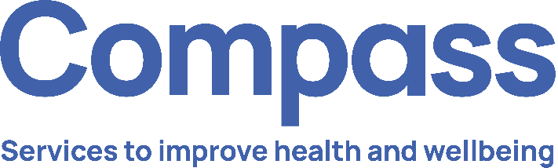
Job Grade: | G
Reports To: | General Manager – School Health
Service Overview:

Tower Hamlets Young Health hub is a truly integrated early intervention and health promotion public health service for children, young people and their families living in the London Borough of Tower Hamlets. The service provides a unique multi-professional school health and wellbeing model delivered to children, young people and families (CYPF) in an accessible way in schools and communities.
The service provides a range of clinical and non-clinical health and wellbeing interventions alongside health promotion activities, including:
- School Nursing
- National Child Measurement programme.
- Early Intervention Substance Misuse and Risky Behaviours.
- Sexual Health
- Oral Health
- Community awareness raising.
- Vision and Hearing Screening.

The Young Health Hub works collaboratively with communities, partners and CYPF to design, develop and deliver holistic wellbeing services which reduce long-term ill health, remove or reduce health inequalities and create opportunities for CYPF to take and sustain positive health promoting action.
Job Purpose:

The Oral Health Clinical Manager will be an active member of the Young Health Hub Leadership Team and provide managerial and clinical supervision, advice and strategic leadership to the Oral Health Service.

The Clinical Manager will line manage Dental Therapists and Oral Health Coordinators and ensure a systematic, organised and accessible oral health service is delivered in schools and communities across the London Borough of Tower Hamlets. The Oral Health Clinical Manager will work both independently and as part of a multi professional team around the family to deliver positive dental health outcomes to children and young people.

Safeguarding will be an integral aspect of the role.

As a qualified and experienced dental professional Clinical Manager will provide professional leadership, teaching/coaching and maintain oral health services in line with best evidence and contemporary practice supporting the team and enabling the efficient, effective and safe delivery of oral health services. This will include maintaining own clinical skills and undertaking observed practice in the supervision of other dental health professionals.

The Clinical Manager will work across the Young Health Hub Service to integrate oral health promotion and to establish and maintain effective clinical and operational governance.

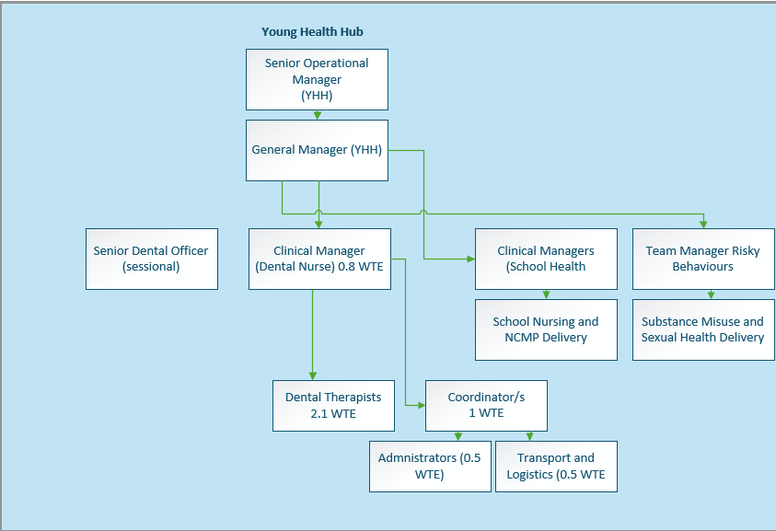

Key Duties and Responsibilities:

- Operational

  - Oversee the assessment, planning, implementing and delivering a range of children and young people’s oral health services in schools and communities across Tower Hamlets
  - Oversee the planning and co-ordination of the annual activity cycle to deliver the Fluoride Varnish (FV), Supervised Toothbrushing (STB) and Brush for Life (BfL) programmes.
  - Plan, create and implement a programme of oral health promotion within the school-based health and wellbeing model and across community venues.
  - Oversee and manage members of the oral health team to deliver effective, high quality, responsive and child-centred services.
  - Provide clinical supervision to dental health professionals in the team and ensure all team members have access to appropriate clinical and managerial supervision.
  - Lead, manage and integrate the key duties and responsibilities of the oral health team ensuring referral on to specialist agencies appropriately when required.
  - Apply and develop local systems, processes and practices within the oral health services that are consistent with the Young Health Hub and corporate working approach.
  - Support the General manager and Senior Operational Managers in the delivery of Compass’ Clinical Governance framework, policies and procedures within the oral health service.
  - Contribute to monthly and quarterly activity reporting through the collation, analysis and evaluation of performance data
  - Lead and support Dental Practitioners to develop and deliver annual Oral Health planning.
  - Undertake and/or delegate STB compliance audit in settings, identify areas for improvement and support all settings to meet the minimum required standards.
  - Provide regular individual and/or group supervision, annual appraisal and individual performance assessment linked to service KPIs as outlined in Compass frameworks, policies and procedures
  - Actively work towards developing and sustaining effective working relationships with partner agencies setting in place effective Joint Working and Information Sharing Agreements as required.
  - Leads on establishing, monitoring, auditing and maintaining high levels of infection Prevention and Control standards.
  - Leads on the design, development and reporting from oral health service data systems to deliver on robust consent recording, pathway management and activity reporting.
  - Lead the team on national dental epidemiology surveys and school-based screening programmes

- Developing and Maintaining Relationships

  - Create and sustain effective relationships with Health Visiting colleagues to agree the operational design and distribution of BfL packs to under 5’s.
  - Be proactive in engaging, outreaching and developing accessible and acceptable services for all in scope schools and the wider community of eligible children and young people
  - Work with partners and stakeholders to create pathways and access for children, young people and families (CYPF) who may otherwise not engage in oral health programmes.
  - Lead on the strategic partnerships in Tower Hamlets with schools, Local Authority, Public Health to identify oral health priorities and set in place actions to address.
  - Work proactively with settings/leadership teams to promote oral health delivery acting as a positive advocate and problem solver to maximise engagement.
  - Be an active member and contribute to local operational and strategic meetings to represent the service and organisation and build sustainable partnerships with priority partners
  - Effectively leads the oral health team in order to deliver results; inspiring others to be positive in their everyday practice, service delivery and development
  - Effectively work as part of a local management team to ensure the delivery of a uniformed and cohesive services across the Borough.
  - Lead and develop a cohesive team that works effectively together to find solutions
  - Be a proactive member of the wider Compass management team and reflect Compass’ values
  - Build strong links with key departments within Compass and develop key relationships with colleagues in other services.
  - Works collaboratively with the Young Health Hub colleagues to plan integrated, holistic and cohesive public health campaigns for oral health, diet, weight and associated health priorities.

- Managing Resources

  - Ensure adequate cover for the service throughout the year in collaboration with Team Members adopting a corporate working approach, flexible cover for absence and in contingency to maintain direct delivery or oral health services.
  - Overall responsibility (Through a scheme of delegation) for the planning, ordering, stock control, storage and delivery of sufficient BfL packs, STB equipment and Fluoride Varnish
  - Makes provision for the availability of suitable clinical and non-clinical equipment necessary for the safe and effective delivery of oral health care to children and young people.
  - Management of Clinical Waste contracts; monitoring and maintaining the safe and effective Clinical Waste Practice in the oral health service.

- Managing Self

  - Prioritise own workload within agreed objectives using own initiative.
  - Take responsibility for own learning and professional development in line with Compass’ Learning and Development framework and maintain compliance with mandatory training requirements of the role.
  - In conjunction with line manager, take responsibility for shaping and directing an assigned equalities themed lead area of work and supporting others in the development of their themed/high impact area
  - Take responsibility for own and others’ health and safety in the working environment.
  - Promotes equal opportunity and diversity within Compass.
  - Ensure that confidentiality is upheld at all times in line with Compass policy.
  - Ensure safeguarding responsibilities are delivered in line with role and competency level.
  - Work in accordance with Caldicott principles and Data Protection principles and adheres to all relevant Compass policies, procedures and guidelines
  - Maintain accurate records in line with the Compass policies and procedures
  - Skilful at managing conflict that may arise whilst working on behalf of Compass
  - To act as a role model in applying good infection control prevention and control policy and practice within Compass.
  - Maintains own professional registration.
  - Participates actively in own development, supervision and appraisal with the General Manager and Senior Dental Officer.

5. Flexible Approach
To undertake any evening or weekend working as required; periodic, planned work outside of normal working hours may be required from time to time to engage in schools/setting with parents and strategic partners.
To carry out such other duties commensurate with the grading of the post as may be reasonably determined from time to time.

In line with Compass Values and Character be a creative problem solver, flexible and proactive in enhancing, developing and promoting delivery and reputation of the oral health service.
6. Financial Responsibilities: Manages the resources of the oral health service within a defined budget and in line with Compass Financial Standing Orders.
7. People Responsibilities: Leads the team; providing direct and indirect supervision, effecting strong team culture of compassion and competence. Leads the oral health team to maintain the highest standards of service, conduct, attendance and attainment. Takes a lead in the recruitment and retention of roles withing oral health.

Qualifications, Experience and Knowledge:

ESSENTIAL
Qualifications

- BSc degree/Diploma in Dental Therapy or equivalent.
- Current General Dental Council (GDC) registration.
- Certificate in Fluoride Varnish Application
- Post graduate qualification (or equivalent experience) in oral health education.

Experience

- Dental Nursing experience of delivering oral health services in schools and communities to children and young people.
- Leading a team or individual practitioners in the delivery of oral health services.
- Administration of fluoride varnish for children and young people.
- Delivery of oral health promotion to children, young people and families.
- In the use of Microsoft packages.

Knowledge

- Oral health education
- GDC standards and
- Oral health pathways including secondary and specialist care.
- Safeguarding children and vulnerable adults legal frameworks and relevance to practice.

Personal

- Registered with the General Dental Council
- Developed communication skills; and the ability to communicate effectively with children, young people or adults who are or may become distressed.
- Ability to travel independantly, efficiently and frequently across the London Borough of Tower Hamlets.
- Ability and willingness to travel across England on an occasional and planned basis.
- Evidence of continuing professional development.
- Team Player with a ‘Can Do’ attitude.
- Flexible, punctual, able to work with competing demands and to deadlines.
DESIRABLE
Qualifications

- Leadership qualification or equivalent experience. Familiar with dental software computer package(s) Competent use of Microsoft office programmes

Experience

- In the use of dental software computer package(s) in school oral health.
- Clinical supervision of dental nurses/practitioners.
- Working in a multi-agency and/or multi professional context.

Knowledge

- School health policy and practice.
- Approaches to addressing health inequality and delivering oral health services to all sectors of the community.
Personal

- Driving License

Key Competencies/Personal Attributes:
The post holder must demonstrate strengths in the following competency areas:

- Team Player – able to work as part of a team, co-operate to work together and in conjunction with others and willing to help and assist whenever possible and appropriate.
- Interpersonal skills – able to develop, establish and maintain positive relationships with others both internal and external to the organisation.
- Strategic Thinking – able to identify and manage risk.
- Confidence and Presentation Skills– able to deliver messages in a confident manner, with excellent presentation skills and group work skills.
- Communication skills – excellent communication skills (both written and verbal) and ability to adjust communication style and content to the audience.
- Resilience and Workload Management – able to work under pressure, dealing with peaks and troughs in workload and see tasks through to completion when under pressure.
- Flexible & Adaptable – positive attitude to dealing with change; flexible and adaptable, and open to exploring new ideas.
- Self-awareness – ability to empathise with others, maturity to admit and rectify mistakes and strong degree of personal integrity to adhere to acceptable standards of behaviour.
- Motivated – highly motivated and reliable and organised to plan and meet deadlines and manage time effectively.

Compass Values:
The post holder must demonstrate exemplary behaviour in all Compass values, personifying the values and inspiring all colleagues to do the same:

We are Solution Focused
We believe in the art of the possible
We believe in being courageous and collaborative

We Act with Integrity
We believe our actions speak louder than words
We believe in asking for and offering help

We are Consistent & Reliable
We believe tenacity leads to success
We believe that no effort goes to waste

We Value Each Other
We believe in treating others as we expect to be treated
We believe everyone has something to contribute regardless of role

Safeguarding:
The post holder must demonstrate and share our commitment to Safeguarding:

- Work proactively to safeguard and promote the welfare of children, young people and vulnerable adults.

Equality, Diversity & Inclusion:
The post holder must demonstrate and share our commitment to EDI:

- Actively support a safe, inclusive team culture where colleagues and service users of all backgrounds feels respected and empowered.

Compass is committed to promoting the welfare of all those we serve, as well as complying with best practice in the application of safeguarding and we expect all staff and volunteers to share our commitment. As part of our safer recruitment process, an enhanced DBS check will be undertaken before appointment as part of our pre-employment checking process and will be rechecked as and when determined by Compass. For further information about what is required in this process please go to www.gov.uk/disclosure-barring-service-check.

Compass is also committed to equal opportunities and expects all those employed or who volunteer to share our commitment.

