Job Title: | Transport and Logistics Assistant | 
Job Grade: | B
Reports To: | Service Coordinator
Service Overview:

Tower Hamlets Young Health hub is a truly integrated early intervention and health promotion public health service for children, young people and their families living in the London Borough of Tower Hamlets. The service provides a unique multi-professional school health and wellbeing model delivered to children, young people and families (CYPF) in an accessible way in schools and communities.
The service provides a range of clinical and non-clinical health and wellbeing interventions alongside health promotion activities, including:
- School Nursing
- National Child Measurement programme.
- Early Intervention Substance Misuse and Risky Behaviours.
- Sexual Health
- Oral Health
- Community awareness raising.
- Vision and Hearing Screening.

The Young Health Hub works collaboratively with communities, partners and CYPF to design, develop and deliver holistic wellbeing services which reduce long-term ill health, remove or reduce health inequalities and create opportunities for CYPF to take and sustain positive health promoting action.
Job Purpose:

Ensuring the procurement of the right oral health products at the right price delivered to the right place at the right time.

The Transport and Logistics Assistant works as part of a multi-professional team to deliver high quality, effective and coordinated oral health and wellbeing services to children and young people across the London Borough of Tower Hamlets.

Principally the Transport and Logistics Assistant is responsible for the day-to-day control and movement of dental health provisions across the borough, this will include the planning and provision of sufficient supplies of dental packs to schools and education settings, health services and community provision.

This will be achieved by undertaking all operational work associated with the requisitioning, receipt, distribution and management of goods to ensure the delivery of outstanding oral health care. Working in accordance with agreed procedures and policies.
Building professional relationships in the implementation and ongoing management of materials ordering, receipt and distribution process

Continuously looking to improve the service delivered to ensure that goods are received and stored safely, and that onward distribution of supplies to end users is undertaken with minimum delay

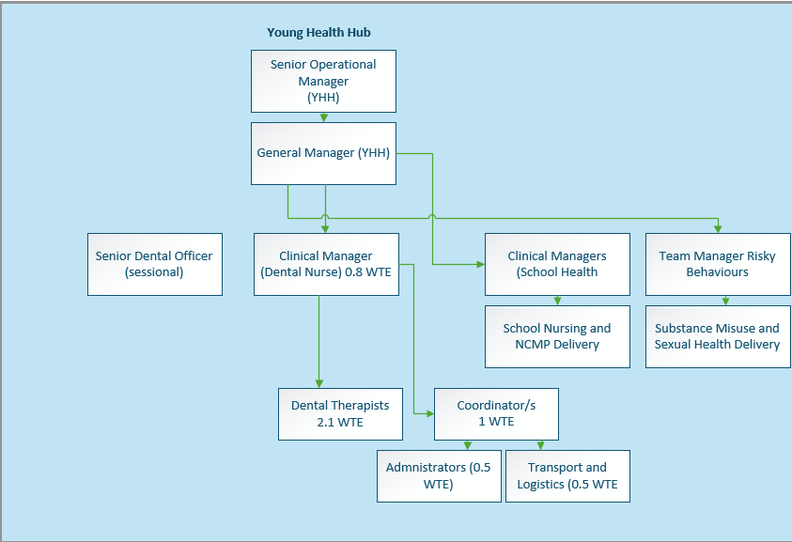

Key Duties and Responsibilities:

- Operational

  - To ensure the routine replenishment of oral health provisions to internal team and across partners schools, education settings and health services.
  - Order sufficient stock to maintain efficient delivery of oral health care and control incoming and outgoing provision and rotation.
  - Maintain up-to-date supplies management catalogues to ensure that they are an accurate record of stock requirements and movement.
  - Undertake delivery of supplies across the London Borough of Tower Hamlets (LBTH). Plan distribution routes to maximise efficiency in order to complete the number of deliveries required.
  - Design and implement processes which provide efficient, environmentally sustainable, recycling practices.
  - Ensure all storage areas are maintained in a clean and tidy condition and that supplies are securely stored.
  - Ensure that the stores environment is secure and that the opportunity for loss, theft and damage are minimised
  - Process all associated documentation, carry out administrative work and maintain all essential records as required and / or directed.
  - Perform data entry tasks as appropriate using the appropriate computer systems.
  - Load and unload vehicles, correctly store goods and marshal delivery vehicles where transport is required.

- Developing and Maintaining Relationships

  - Liaison with end users and colleagues at all levels to ensure materials needs are met and service delivery is maintained.
  - To promote the service to all partners, customers and colleagues acting with care and professionalism at all times.
  - Provide customer service, help and advice, and handle relevant enquiries from internal and external customers where necessary..
  - Contribute to a strong culture of teamwork, share best practice and collaborate with all.
  - Maintain effective working relationships with external suppliers to minimise delays to deliveries and reduce risk of service disruption.

- Managing Resources

  - Perform stocktaking duties, reporting any discrepancies and assisting with subsequent investigation of errors and losses.
  - Receive, inspect and check all goods delivered. Make a decision on acceptance and, where necessary, report any issues to the coordinator. In addition, note and report any discrepancies and/or damaged goods.
  - When delivery discrepancies are reported, to take appropriate action to ensure correct items are provided in timely and efficient manner.
  - Adherence to Standing Financial Instructions and relevant departmental procedures..
  - Buddy, mentor and support the training of new staff and provide cross cover for other team members.
  - Develop and maintain innovative ways to procure goods and services in order to create savings.

- Managing Self

  - Work in an organised manner, keeping all working areas clean and tidy, ensuring safe working environmental practices..
  - Participate in the appraisal process and undertake personal development and team building events to improve own performance and that of the team.
  - Maintain compliance with mandatory training requirements for the role.
  - Take responsibility for own and others’ health and safety in the working environment.

Flexible Approach
- To undertake occasional evening or weekend working as required on a periodic and planned basis.
- To carry out such other duties commensurate with the grading of the post as may be reasonably determined from time to time.

In addition to these functions the post holder is expected to:

- In agreement with the line manager carry out such other duties as may be reasonably expected in accordance with the grade of the post.

Financial Responsibilities: Manages the resources of the oral health service within a defined budget and in line with Compass Financial Standing Orders.
People Responsibilities: None

Qualifications, Experience and Knowledge:

ESSENTIAL
Qualifications

- GCSE English Language and Maths both at Grade C or above or be able to demonstrate an equivalent level of knowledge/aptitude.

Experience

- Experience of working within a fast paced environment
- Experience of using Microsoft systems for the booking in, ordering of goods and materials management

Knowledge

- Knowledge/experience of manual handling procedures and health and safety
- Able to demonstrate an understanding of confidentiality

Personal

- Physically fit and able to undertake manual handling duties.
- Able to drive, travel independently across the London Borough of Tower Hamlets and holds a full UK Driving License
- Able to work as part of a team
- Able to work on own initiative
- Able to keep accurate records
- Proactive, adaptable attitude to work and change to meet service needs - able and willing to adopt new tasks and methods of working as required.
DESIRABLE
Qualifications

- International Certification of Digital Literacy (ICDL).

Experience

- Experience within a Stores or Distribution environment

Knowledge

- Knowledge of receipt, storage and distribution procedures

Personal

- Access to own vehicle for use in the fulfilment of the job for which expenses are paid.

Key Competencies/Personal Attributes:
The post holder must demonstrate strengths in the following competency areas:

- Team Player – able to work as part of a team, co-operate to work together and in conjunction with others and willing to help and assist whenever possible and appropriate.
- Interpersonal skills – able to develop, establish and maintain positive relationships with others both internal and external to the organisation.
- Strategic Thinking – able to identify and manage risk.
- Confidence and Presentation Skills– able to deliver messages in a confident manner, with excellent presentation skills and group work skills.
- Communication skills – excellent communication skills (both written and verbal) and ability to adjust communication style and content to the audience.
- Resilience and Workload Management – able to work under pressure, dealing with peaks and troughs in workload and see tasks through to completion when under pressure.
- Flexible & Adaptable – positive attitude to dealing with change; flexible and adaptable, and open to exploring new ideas.
- Self-awareness – ability to empathise with others, maturity to admit and rectify mistakes and strong degree of personal integrity to adhere to acceptable standards of behaviour.
- Motivated – highly motivated and reliable and organised to plan and meet deadlines and manage time effectively.

Compass Values:
The post holder must demonstrate exemplary behaviour in all Compass values, personifying the values and inspiring all colleagues to do the same:

We are Solution Focused
We believe in the art of the possible
We believe in being courageous and collaborative

We Act with Integrity
We believe our actions speak louder than words
We believe in asking for and offering help

We are Consistent & Reliable
We believe tenacity leads to success
We believe that no effort goes to waste

We Value Each Other
We believe in treating others as we expect to be treated
We believe everyone has something to contribute regardless of role

Safeguarding:
The post holder must demonstrate and share our commitment to Safeguarding:

- Work proactively to safeguard and promote the welfare of children, young people and vulnerable adults.

Equality, Diversity & Inclusion:
The post holder must demonstrate and share our commitment to EDI:

- Actively support a safe, inclusive team culture where colleagues and service users of all backgrounds feels respected and empowered.

Compass is committed to promoting the welfare of all those we serve, as well as complying with best practice in the application of safeguarding and we expect all staff and volunteers to share our commitment. As part of our safer recruitment process, an enhanced DBS check will be undertaken before appointment as part of our pre-employment checking process and will be rechecked as and when determined by Compass. For further information about what is required in this process please go to www.gov.uk/disclosure-barring-service-check.

Compass is also committed to equal opportunities and expects all those employed or who volunteer to share our commitment.

