Job Title: | Administrator | 
Job Grade: | B
Reports To: | Senior Administrator/ Team Leader
Service Overview:

Tower Hamlets Young Health hub is a truly integrated early intervention and health promotion public health service for children, young people and their families living in the London Borough of Tower Hamlets. The service provides a unique multi-professional school health and wellbeing model delivered to children, young people and families (CYPF) in an accessible way in schools and communities.
The service provides a range of clinical and non-clinical health and wellbeing interventions alongside health promotion activities, including:
- School Nursing
- National Child Measurement programme.
- Early Intervention Substance Misuse and Risky Behaviours.
- Sexual Health
- Oral Health
- Community awareness raising.
- Vision and Hearing Screening.

The Young Health Hub works collaboratively with communities, partners and CYPF to design, develop and deliver holistic wellbeing services which reduce long-term ill health, remove or reduce health inequalities and create opportunities for CYPF to take and sustain positive health promoting action.
Job Purpose:

The Administrator will be an active member of the team who will contribute and support the delivery of positive outcomes for children, young people and families. They will support the establishment of integrated administrative systems across the whole service including how information is collected, used, stored and analysed to ensure that services are aligned to best meet local needs and contributes to the annual planning cycle.
They will provide professional information, advice and support to skill mix teams to develop, deliver and maintain effective and standardised information governance systems and excellent customer focused care within the Service. Discretion and confidentiality must be maintained at all times.

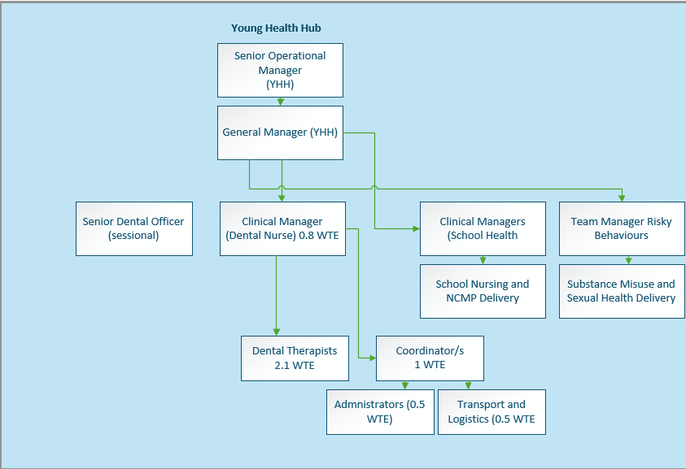

Key Duties and Responsibilities:

- Operational

  - Support all back office and front office administrative functions are customer focused and information governance systems/procedures/practices and consistently applied across the whole service.

  - Support effective and integrated administrative function against standard operating procedures contributing to the provision of a cohesive and equitable service.

  - Support the Senior Administrator and operational/clinical leaders to maintain central coordination of the programmes of activity.

  - Support the delivery, development and integration of all Management Information Systems specific to the service.

  - Support the management of local information governance systems and in particular the safe storage and transportation of clinical records in adherence with Compass IG policies and procedures.

  - Assist with the implementation of digital services for children, young people and families and support the marketing and promotion of the service to a wide range of stakeholders.

  - Support the implementation of key health and safety requirements on a routine basis that will contribute to ensuring safe systems at work.

  - Support the development and production of routine performance dashboard reports to contribute to supervision, appraisal, clinical review meetings and performance dashboards as directed by the Service Manager.

  - Assist with the population of activity data reports on a daily/weekly/monthly/quarterly basis and contribute to the creation of quarterly and annual performance monitoring reports.

- Developing and Maintaining Relationships

  - Be a proactive member of the team and reflect Compass’ values.

  - Actively works towards developing and sustaining effective working relationships with partner agencies in accordance with Joint Working Agreements/Service Level Agreements.

  - Build strong links with key departments within Compass and develop key relationships with colleagues in other services.

  - Take ownership and actively contribute to the development of sustainable partnerships, care pathways and shared expertise through the Compass specialist themed lead function.

  - Work flexibly and creatively within the team and wider service to maintain effective delivery of oral health services.

- Managing Resources

  - Maintain accurate records in line with the Compass policies and procedures.

  - Work with Clinical Manager and Logistics colleagues to maintain adequate oral hygiene supplies and services.

  - Deputise for the Transport and Logistics Assistant during times of absence on an as and when required basis to coordinate delivery of required oral health supplies required to maintain service delivery.

- Managing Self

  - Prioritise own workload within agreed objectives using your own initiative.

  - Take responsibility for own learning and professional development in line with Compass’ Learning and Development framework.

  - Take responsibility for your own and others’ health and safety in the working environment.

  - Promotes equal opportunity and diversity within Compass.

  - Ensure that confidentiality is upheld at all times in line with Compass policy.

  - Ensure safeguarding responsibilities are delivered in line with role and competency level.

  - Works in accordance with Caldicott principles and Data Protection principles and adheres to all relevant Compass policies, procedures and guidelines.

  - To act as a role model in applying good infection control prevention and control policy and practice within Compass.

Flexible Approach
To undertake any evening or weekend working as required; periodic, planned work outside of normal working hours may be required from time to time to engage in schools/setting with parents and strategic partners.
To carry out such other duties commensurate with the grading of the post as may be reasonably determined from time to time.

In line with Compass Values and Character be a creative problem solver, flexible and proactive in
enhancing, developing and promoting delivery and reputation of the oral health service.

In addition to these functions the post holder is expected to:

- In agreement with the line manager carry out such other duties as may be reasonably expected in accordance with the grade of the post.

Financial Responsibilities: Some delegated responsibility by the Service Manager to establish local purchasing procedures for key overhead areas in line with Compass Financial Procedures and Scheme of Delegated Authority.
People Responsibilities: None

Qualifications, Experience and Knowledge:

ESSENTIAL
Qualifications

- NVQ level 3 Business Administration or equivalent
- Level 2 IT skills i.e. RSA or equivalent experience

Experience

- Working in a busy office and customer service environment
- Working to deadlines and managing multiple projects
- Using a range of management information systems including extracting and collating data
Knowledge

- IT skills
- Good communication and interpersonal skills
- Able to organise workload and demonstrate time management skills
- Attention to detail and accuracy
Personal

- Work under pressure and able to manage changing priorities
- Ability to show empathy
Able to work as part of a team and willing to help and assist
- Able to develop, establish and maintain positive relationships with others both internal and external
- Positive attitude; flexible and adaptable; solution focused; and tenacious.
- Be flexible and adaptable to meet business need
- Has a strong degree of personal integrity.
DESIRABLE
Qualifications

- English Language & Maths to GCSE A-C level or equivalent.
- Customer care experience/qualification e.g. NVQ Level 3
Experience

- Analysing data and trend analysis
- Using digital technology to deliver services and use of social media

Key Competencies/Personal Attributes:
The post holder must demonstrate strengths in the following competency areas:

- Team Player – able to work as part of a team, co-operate to work together and in conjunction with others and willing to help and assist whenever possible and appropriate.
- Interpersonal skills – able to develop, establish and maintain positive relationships with others both internal and external to the organisation.
- Strategic Thinking – able to identify and manage risk.
- Confidence and Presentation Skills– able to deliver messages in a confident manner, with excellent presentation skills and group work skills.
- Communication skills – excellent communication skills (both written and verbal) and ability to adjust communication style and content to the audience.
- Resilience and Workload Management – able to work under pressure, dealing with peaks and troughs in workload and see tasks through to completion when under pressure.
- Flexible & Adaptable – positive attitude to dealing with change; flexible and adaptable, and open to exploring new ideas.
- Self-awareness – ability to empathise with others, maturity to admit and rectify mistakes and strong degree of personal integrity to adhere to acceptable standards of behaviour.
- Motivated – highly motivated and reliable and organised to plan and meet deadlines and manage time effectively.

Compass Values:
The post holder must demonstrate exemplary behaviour in all Compass values, personifying the values and inspiring all colleagues to do the same:

We are Solution Focused
We believe in the art of the possible
We believe in being courageous and collaborative

We Act with Integrity
We believe our actions speak louder than words
We believe in asking for and offering help

We are Consistent & Reliable
We believe tenacity leads to success
We believe that no effort goes to waste

We Value Each Other
We believe in treating others as we expect to be treated
We believe everyone has something to contribute regardless of role

Safeguarding:
The post holder must demonstrate and share our commitment to Safeguarding:

- Work proactively to safeguard and promote the welfare of children, young people and vulnerable adults.

Equality, Diversity & Inclusion:
The post holder must demonstrate and share our commitment to EDI:

- Actively support a safe, inclusive team culture where colleagues and service users of all backgrounds feels respected and empowered.

Compass is committed to promoting the welfare of all those we serve, as well as complying with best practice in the application of safeguarding and we expect all staff and volunteers to share our commitment. As part of our safer recruitment process, an enhanced DBS check will be undertaken before appointment as part of our pre-employment checking process and will be rechecked as and when determined by Compass. For further information about what is required in this process please go to www.gov.uk/disclosure-barring-service-check.

Compass is also committed to equal opportunities and expects all those employed or who volunteer to share our commitment.

